Input tool using base Unity by Donovan Colen

HOW TO USE:

1. Attach the Custom Input script to the object you want receiving input.

2. Setup the array with the string name of the desired input and the function you want called for that input.

a. For keys/buttons you can use the Assign Key during runtime in the editor to have the script catch the next input from keys/buttons for you.

b. For axis input the axis must be setup in the Input Manager settings for the current project. To edit them Edit>Project Settings>Input. For standard axis input the function must take a float as a parameter and be sure to select the dynamic version of the function.

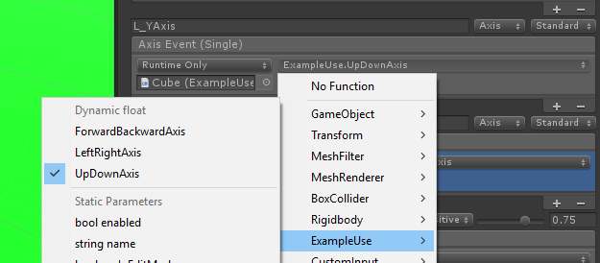

c. You can use the save/load buttons at the bottom of the array to save/load edits during runtime. The save file is saved in XML format so it could be edited.

d. Touch and Acceleration input is NOT supported.

3. For Combo type input the string needs to be in the format "key/button/axis+key/button" or "axis1, axis2+key/button". IMPORTANT "axis+axis" combos is NOT supported.

a. For axis combos direction of each axis Positive (Up/Right), Neutral (no axis input), or Negative (Down/Left) determines the direction the stick needs to be to call the function. For diagonal directions both the X and Y axis for the joystick must be passed in and the directions of both sticks are combined to make the diagonal direction. For example axis1 (Positive) and axis2 (Positive) is the diagonal up-right. NOTE if the axis is inverted use the invert box in the Input Manager to fix it.

4. For Sequence type input must be separated by ", ". For example: W, W, S, S, A, D, A, D, B, A, Return. Then enter the time limit (in seconds) for inputting the sequence.

a. Putting zero or a negative time limit means there is infinite time to complete it.

b. Sequences are done on down for the button presses. So combination input in sequences can be finicky.

c. For axis input in sequence the direction is determined by the characters: < (negative), = (neutral), and > (positive). With combo and axis an example is: DPad_YAxis>, DPad_YAxis>, DPad_YAxis<, DPad_YAxis<, A+D, A+D, B, A, L_XAxis+JoystickButton1<, (L_XAxis, L_YAxis+JoystickButton0<>), (L_XAxis, L_YAxis>>), Return.

d. The Axis Tolerance for sequences applies to all the axis inputs used in sequence, so putting values higher for either axis above 0.7 may stop diagonal axis input. NOTE axis input for sequences do NOT reset the sequence for being incorrect because they made the input too sensitive and checking all axes for input would be too complex.

5. Play the scene to test the input and tweak as needed. If needed check out the sample scene for help. You can also contact me for assistance with the tool at surefireace@hotmail.com.